Experimental Results--No.2

Total Time：126 min

1. Use Case Diagram

Time：6 min

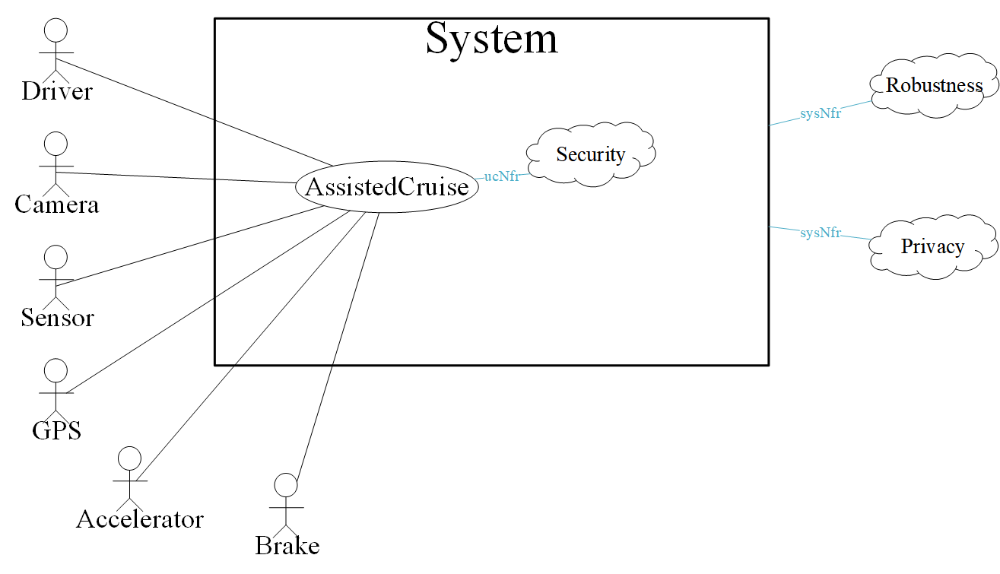

1. System Sequence Diagram

Time：70min

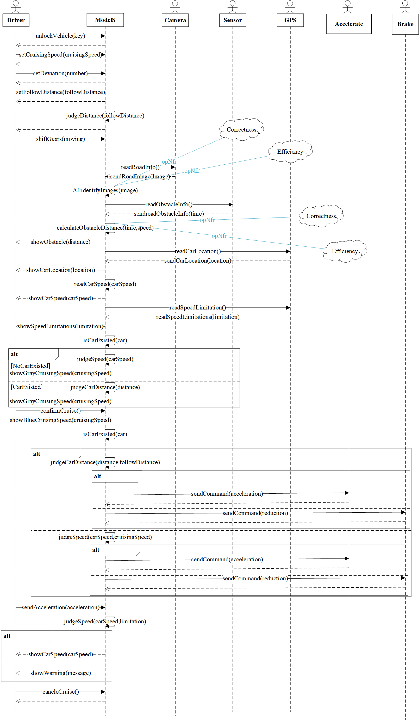

1. Conceptual Class Diagram

Time：25min

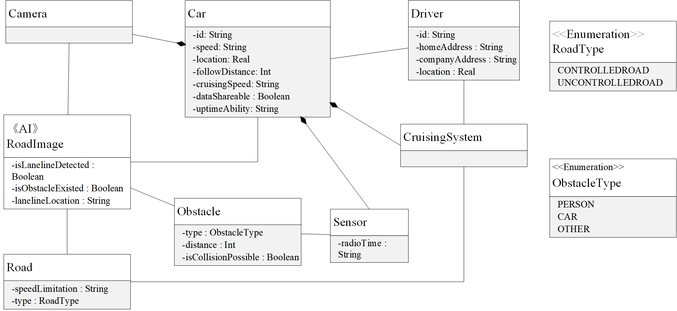

1. Context Diagram

Time：17min

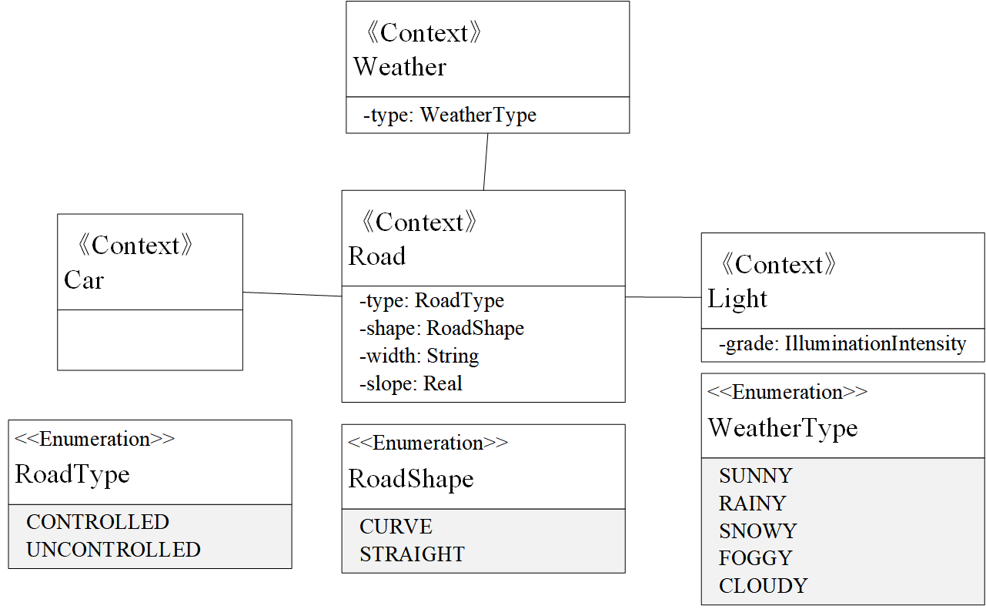

1. Machine Learning Diagram

Time：8min

